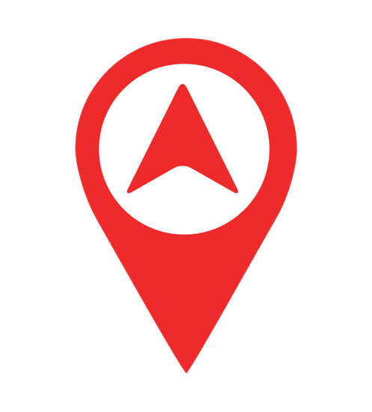

Navigettr

## Screen 1 – Splash Screen

**Namespace** - com.navigettr.app

Splash screen – will provide the logo at the end of the development.

 Navigettr 

**Money Transfer Foreign Exchange So**

From Currency List

To Currency List

Amount Text Field –

3 to 7 digits

**Search**

## Screen 2 – Home Screen

1. Turn on the Location service on this screen like Google Pay. App should not get closed in order to turn on the location
2. Currently we will have only offering – Money Transfer. Other are possible tabs. I have added two dummy tabs – Foreign exchange, something else.
3. User must provide all three fields in order to search. Along with that – latitude & longitude are also required.

Brand Logo

 Navigettr 

**FILTER BY RATE BT DISTANCE**

**40 money transfer providers available.**

1 AED = **15.5** INR

5 KM away

**Open Now**

Brand Name

Offers (Show only when user is logged in)

## Screen 3 – Search Results Screen

1. Green dot is map view icon. I am open for rearranging the options in screen so that it looks good.
2. Currently we don’t have anything to filter but kept the place holder so that when other services are activated – filter option is available
3. Red dot is call icon
4. Green dot above red dot is navigation icon which shall open map view (in app) and show navigation to the destination from user’s current location
5. Up on reaching the destination – app should notify user that user has reached destination (like Ola)

 Navigettr 

**FILTER Sort By RATE**

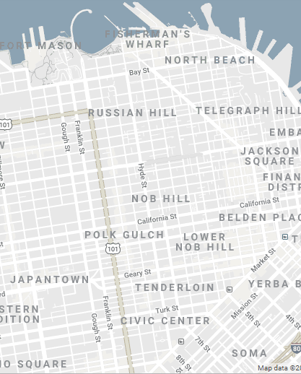

## Screen 4 – Search Results Screen – Map View

1. Blue icon – it is list view icon to switch back to list view
2. When sort by is by rate - the pins should be shown in green which are having highest rates. Gradient pin color from green to red based on rates (highest to lowest)
3. When sort by is by distance – the pins should be shown in green which are closest to current location of user. Farthest pin should be in red.
4. Open popup when user clicks on marker. The popup should show all the information which is visible in list view about that location (rate/open location/brand name/logo/offers).

 Navigettr 

Home

Login

Register

Rewards

Logout

## Screen 5 – Side Menu

1. Menu options in green color are visible post login
2. Menu options in red color are visible pre-login

**$ 10 Earned**

 Navigettr 

<Scan QR code to earn points>



Text in popup - You have earned $10 at Brand Name on March 27, 2019.

## Screen 6 – Reward Points

1. Scan QR code is button which will help scanning the QR code
2. Post QR code scan – API shall be called to claim the reward points.
3. Tiles of $10 will show the previously earned points. This will be through GET API integration. The tiles will be something like Google Pay Rewards.
4. The text should be displayed in modal popup when user taps on any of the reward tile.